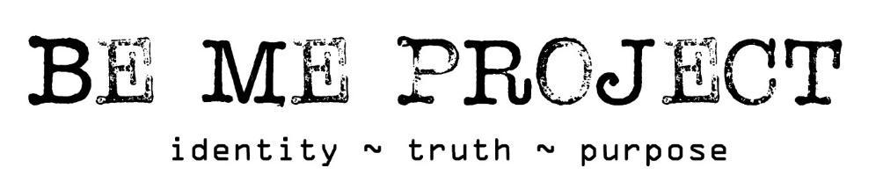

Be Me project safeguarding procedure – PLEASE READ
Be Me project’s Safeguarding Contacts:
Designated Safeguarding Lead: Lucy Mason - lucy@bmeproject.org
Deputy Designated Safeguarding Lead: Sue Gledhill sue@bemeproject.org
Trustee Safeguarding Lead: Elisabeth Moffatt
Updated 11/22
Be Me project seeks to work in partnership with schools and other agencies, and would look to work together and in the best interests of all course attendees. To enable this there are a couple of important procedures we will need to follow as a Charity.
Could you please provide, prior to Be Me project course commencement, the following to the Designated Safeguarding Lead, Lucy Mason (email above).

- Name of Safeguarding Officer
- Contact details (email and telephone number) of the safeguarding officer
- School or Be Me project partner’s safeguarding policy

Be Me project Incident Form
If there is an incident that causes emotional or physical harm to a course attendee during a Be Me project course we will seek to find your safeguarding officer to report the incident and then complete our incident form and e-mail it to the Safeguarding Officer as soon as possible thereafter.
Be Me project Expression of Concern Form
If knowledge of a safeguarding matter arises within a Be Me project course, we will complete our Expression of Concern form and email it to the Safeguarding Officer. If an attendee is at risk of significant harm we will seek to find and report the matter to find the safeguarding officer immediately and follow up with an emailed completed Expression of Concern form.
Be Me project’s submitted forms
To comply with Be Me project’s safeguarding policy and ensure any Incidents or Expressions of Concern have successfully been recorded, and will be appropriately dealt with, we would ask the Safeguarding Officer to acknowledge receipt of the respective form (no details of names or action taken are required) to the Designated Safeguarding Leader (address above).
In the event that a form is submitted to the Safeguarding Officer and we do not receive email confirmation that the form has been received and that the matter is being dealt with, we will be required to report the incident(s) or Expression of Concern Form to the Head Teacher and outside agencies as appropriate. We aim to report within 24 hours to the school and if we do not receive an acknowledgement within 7 days (24 hours for a time-critical concern), we will report directly. For community courses referral should be made directly by one of the safeguarding leads.
Digital platforms (due to Covid 19)
Where the use of digital platforms are in use due to Covid 19. Be Me Project must follow the schools/partnership protocol. All video sessions must be recorded and stored in the schools/partnerships ‘cloud’, (if this follows the schools procedures). If any safeguarding issues arise, the video must be sent to the DSL of the school/partnership. Be Me Project staff must follow the procedure above to notify Lucy Mason DSL of Be Me Project. Where Be Me Projects laptops are in use the recorded sessions must be stored in the Be Me Project Google Cloud for one year only.

